JUNE & JULY
MONTHLY REPORT

The months of June and July are the last months for the school year 2020-2021. But because of the pandemic, we still don’t have a graduation. Before their graduation preparation we first had a one on one evaluation so we would know if they had learned our lessons throughout the year.
For this evaluation also we will know who are the outstanding. The evaluation is for reading, writing, recognizing letter and number, the last one was writing there full name. We do this last June 14 to 16, 2021 I am happy for the result because I see that they can recognize the letter and number, the most important is they all can write their name without the help of their parents or copy. They can write it without a copy that was a big achievement because we are only doing an online class to teach them but they still understand and follow my instruction, with the help of their parents they can follow our lesson.
After the evaluation we prepare for the award and certificate that I will to them not only for my student also their mother will received a certificate because they also achieved the online class of their child is not easy for them because it’s been challenging not only for us as a teacher but also for them as a mother they need to guide their children in learning even if they have gone through the modular and online class they strive to learn it and keep up so that they can guide their children. So I salute to all the parent who is chosen to let their children continue their education even though they know the new way of learning is not easy.
Last June 28, 20201 they received some food packs and vitamins from brgy council parent get it in liban day care center, Our parents are thankful to received it they did not imagine that the council will give that to them. And also we are thankful to our brgy captain for giving that food packs for our students.
July 5, 2021 was the day that they received their award also their parents can received a certificate, because of the guideline that we need to follow we can’t do a ceremony or program for that event so that parents will be get the award of their child. They are only go in my house to received it and after that they just send a picture in our group chat that their child wear there medal and handling their certificate.
Our moving up was virtual , I will do a video like last year because of the pandemic we can’t have a face to face moving ceremony we just do it like a video and their parents can watch it online and I will post it in Facebook. We hope that tis pandemic will end so that we can do a face to face class and we can do all program that we wanted.

Evaluation
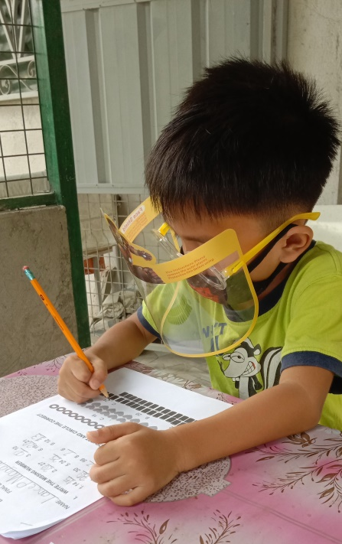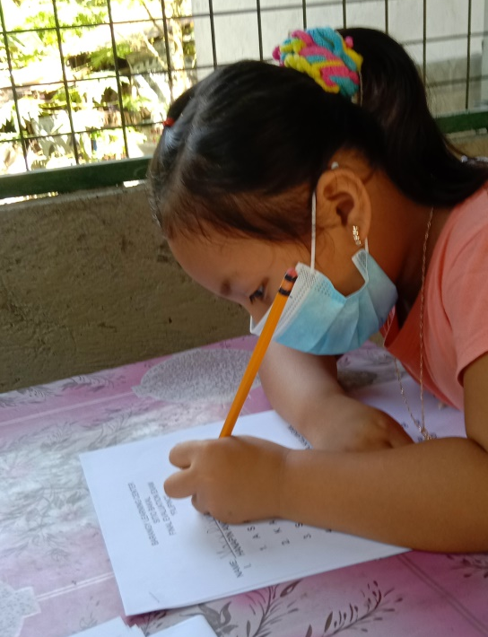
Food pack distribution for students
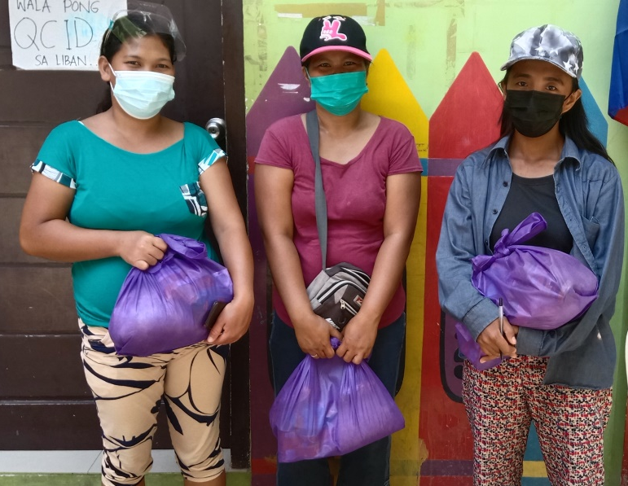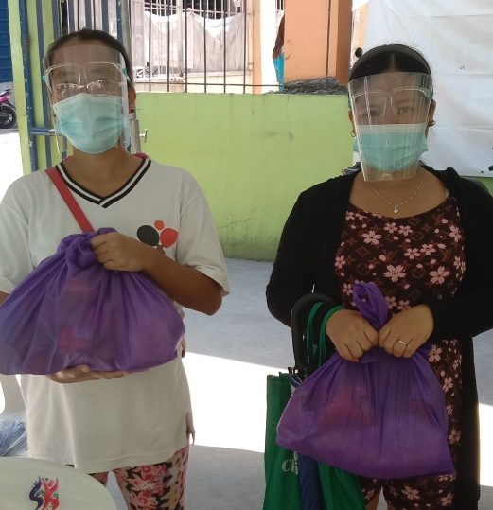

Awarding / Picture with toga


