APRIL & MAY
MONTHLY REPORT

For these two months we continue our daily routine of teaching, I’m glad that they still attending our online class even it’s not easy but they are willing to finish this school year.

Last April, we continue teaching them our topic was writing number 1 to 100, Reading 2 syllables word in Tagalog and English. I’m glad to see and hear that they can recite all of that to me even it’s not perfect but they still know how to read and recognize it. Parents are the most helpful for this because they are my assistant in teaching their child. Last April 24, they received food pack, toys, coloring book from one of NGO here they give us some food pack so that we give it to all the kids in our community. We see the smile in there face to receive that small gift and I’m happy to see it.

For this May, We teach them about days in a week and 12 months in a year. They also start writing there name without the help of their mother even in writing numbers and letter they will write it without copy, I will tell them what will they write then they will write it in there white board. We do this like spelling so that they will always remember to write it. We do that every online class, I’m glad because they follow me correctly you will see the willingness in there face. We also doing art class every Friday so that they will try drawing a things even we are in new normal school.

Now that we hear from our department that we still not have face to face class, we can’t still do our graduation program this year so that we will just give them a certification and award to proving that they have graduated in Kindergarten. But before that we will have a final evaluation so that we will know there academic rate.

DAILY ONLINE CLASSC

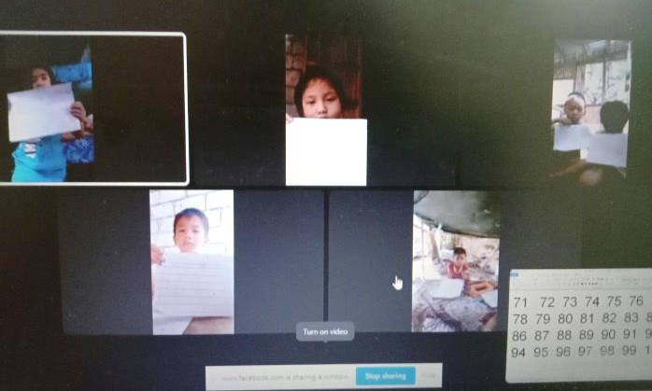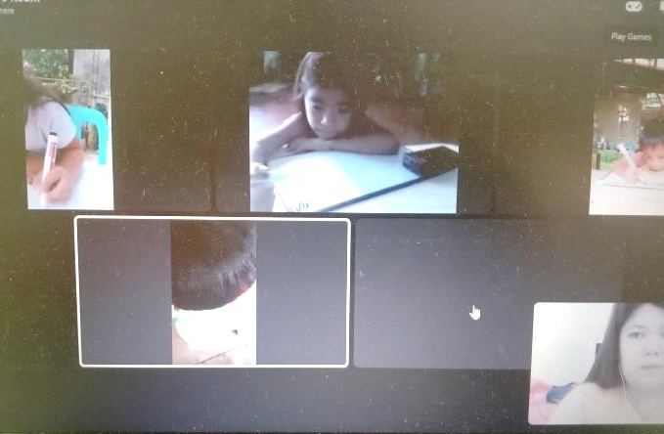

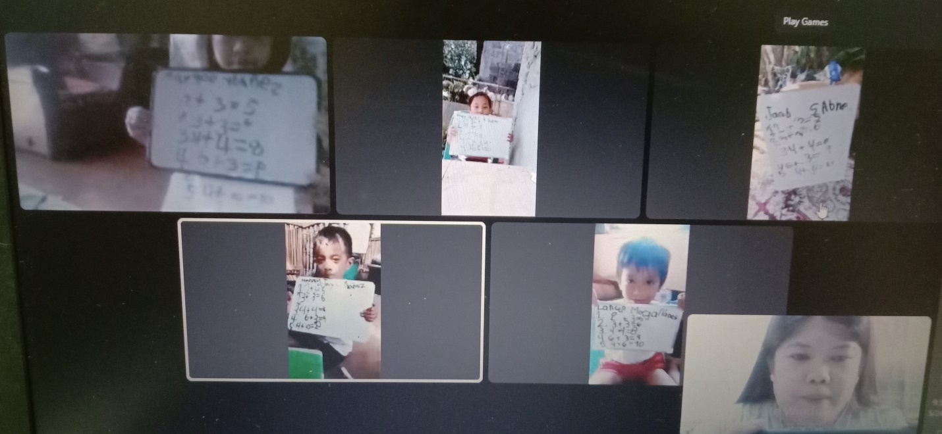

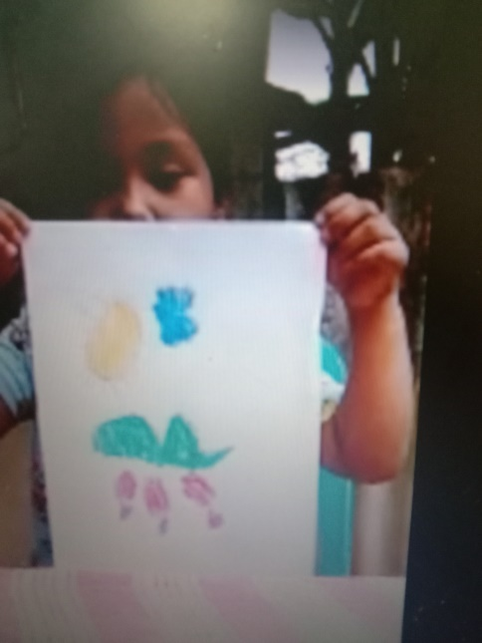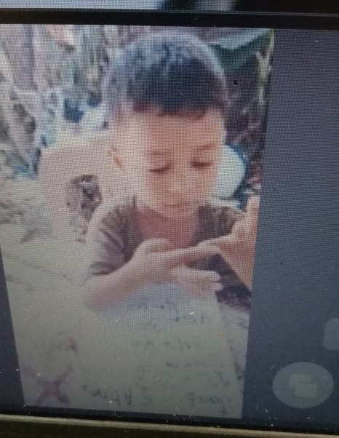

RECEIVING FOOD PACK AND TOYS FROM NGO



