MONTHLY REPORT FOR THE MONTH OF
NOVEMBER AND DECEMBER

For this two months there’s so many thing happened that we did not expect. Last November 12, 2020
Philippines hit a typhoon Ulysses we did not expect his effect to us. Some of the family suffered because of the flood. Bagong Silangan is one of the area who are suffered in flood, All of low area was flooded also are community. You cannot see the house all you can see was water, the saddest thing is its evening when that happened so that we did not sleep on that night. We feel that what happened in last 11 years will happen again in that night. After one day we saw what’s the effect of typhoon, some of the family don’t have a house to stay and some of them have a damage there houses not only there house but also all of their things and clothes was gone.
My Day Care Center also have flood some of my things was damage, my two table was totally damage because I protect my books, and some of important things like the battery and inverter of solar. I’m still thankful because my solar did not fall and damage because one of my roof gone that why we repair it. So that the rain can go inside. Many of my students were suffer in flood that’s why I ask help to my organization and some of my friend to help them. We give them some food packs, clothes, hygiene kit. Now I try to find some sponsor for their school supply because all of them lost their school supply.
We resume are class after one week, as of now I give them a module to answer and one pencil every students so that they can used it when we have online class. Im glad that they still want to study even if their supply are limited.
For this Dec. we only have two weeks to come before Christmas Vacation , I print module to give them so that they can still study it, while in vacation. Now I prepare some gift for them so that they can still happy for this Christmas because when I ask them what they want in Christmas some of them told me that they want toys because there toys was gone when the typhoon hit. And some of them want a new books and crayon because they lost it when the typhoon hit. So that I prepared some gift to them.

Online class
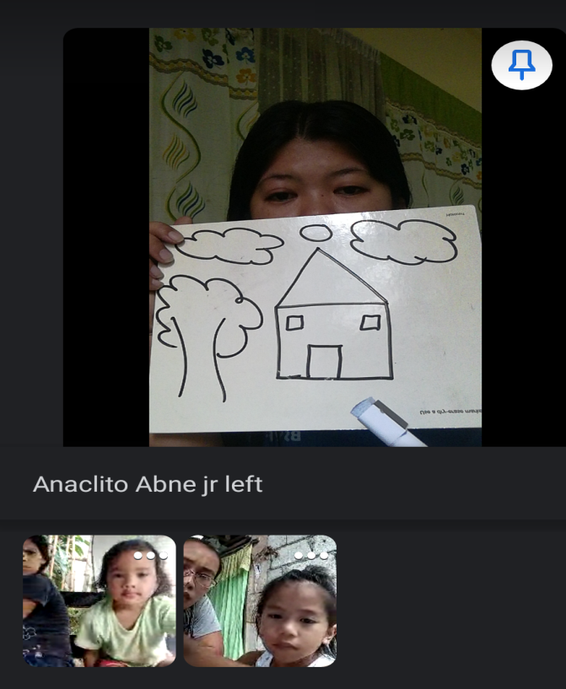
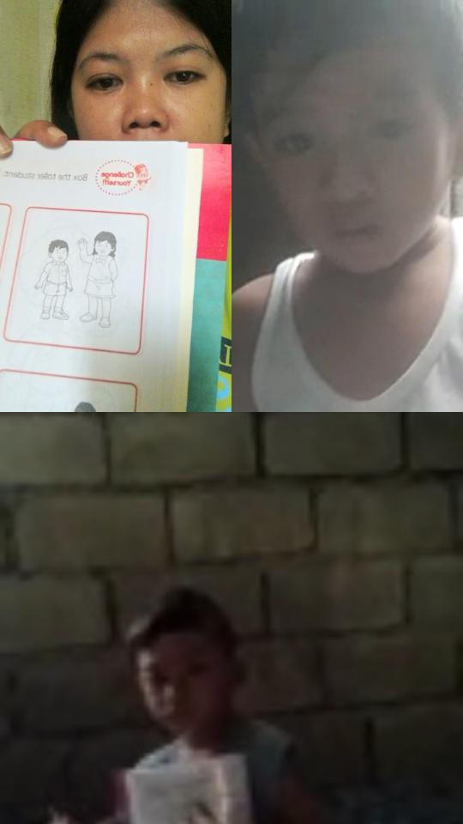

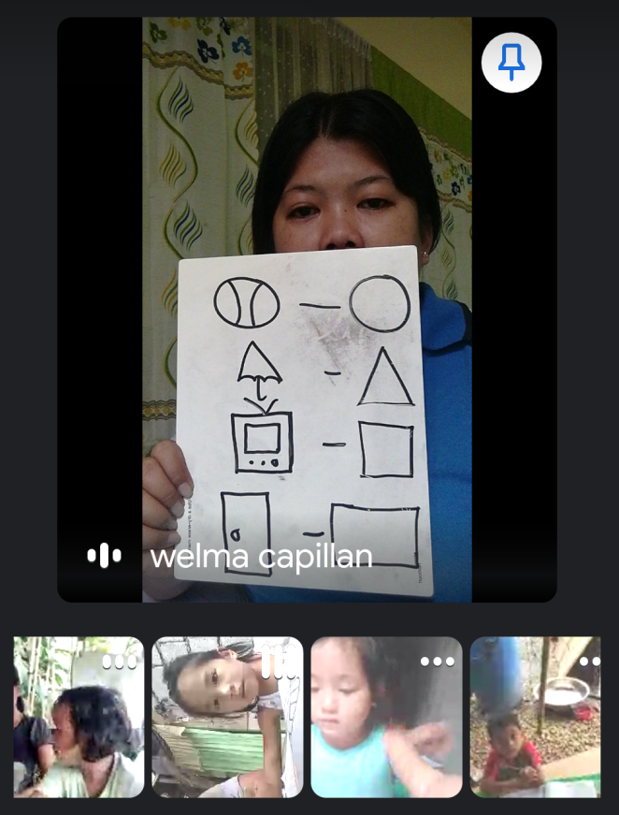
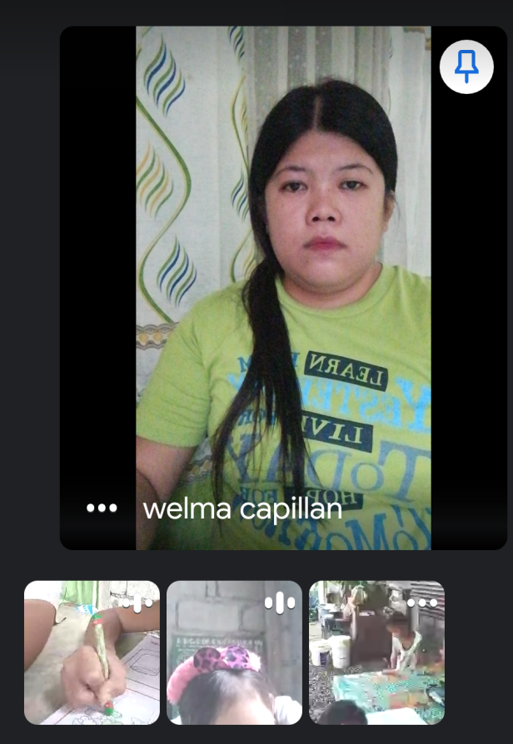

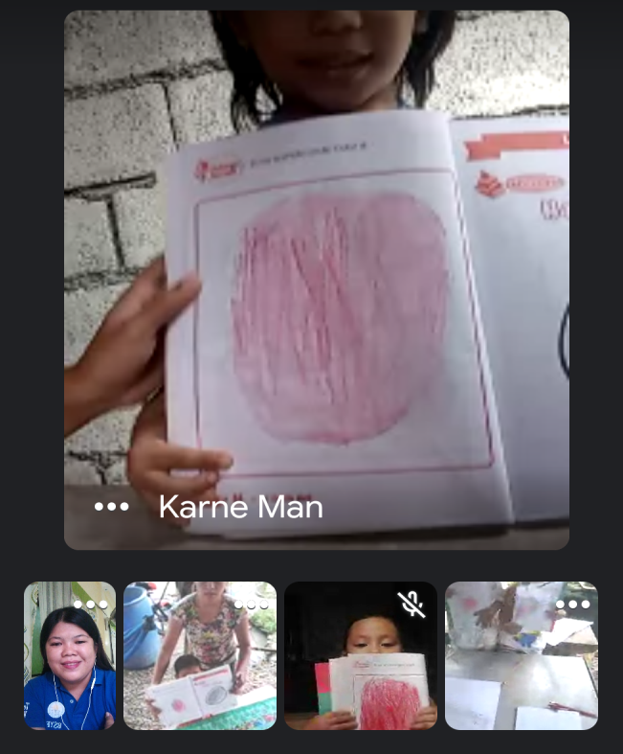
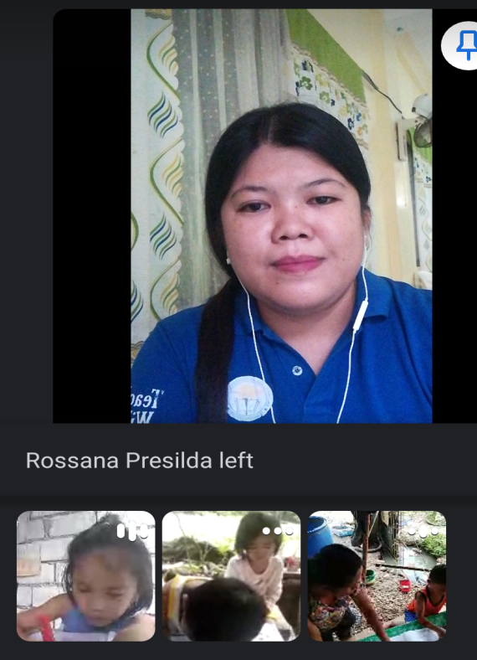

EFFECT OF TYPHOON ULYSSES / GIVING FOOD PACKS & CLOTHES
IN AFFECTED FAMILIES.
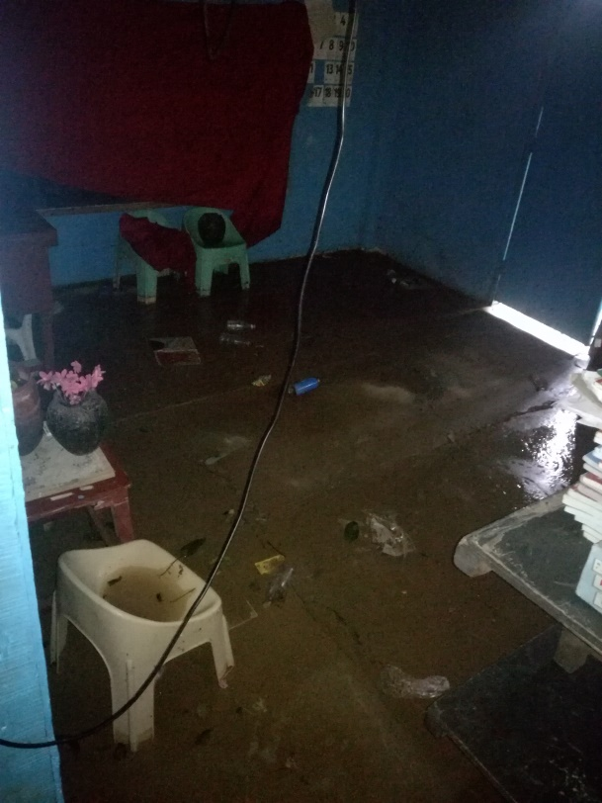
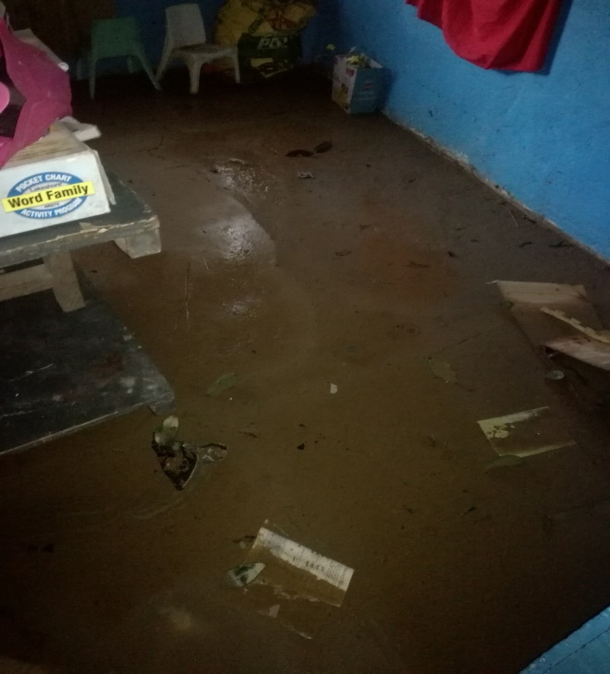

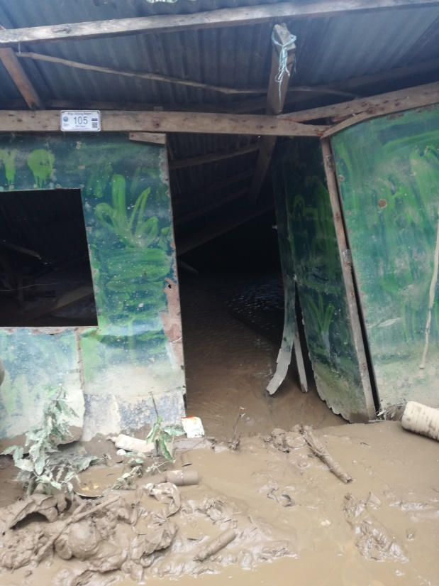
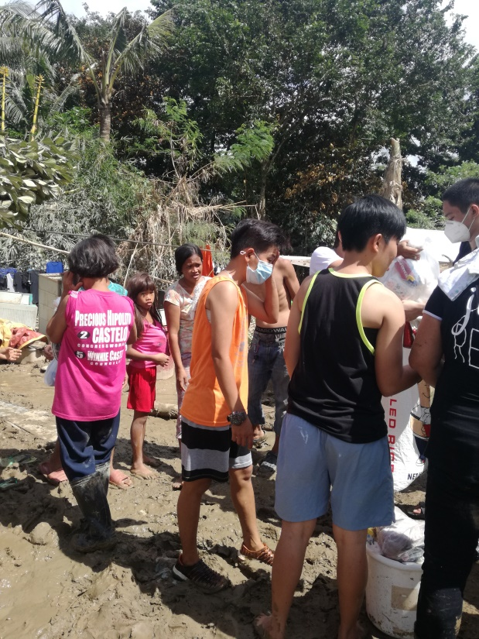

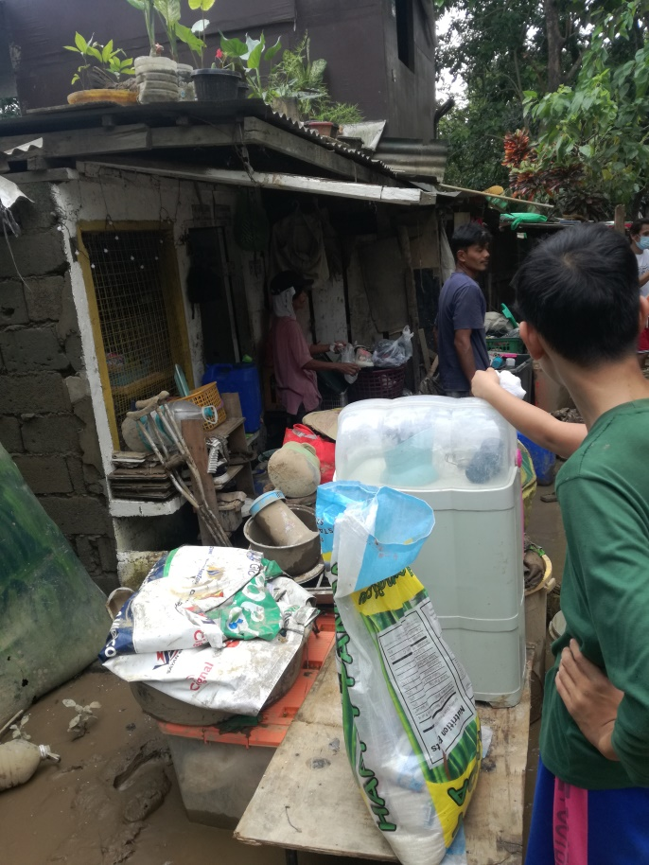

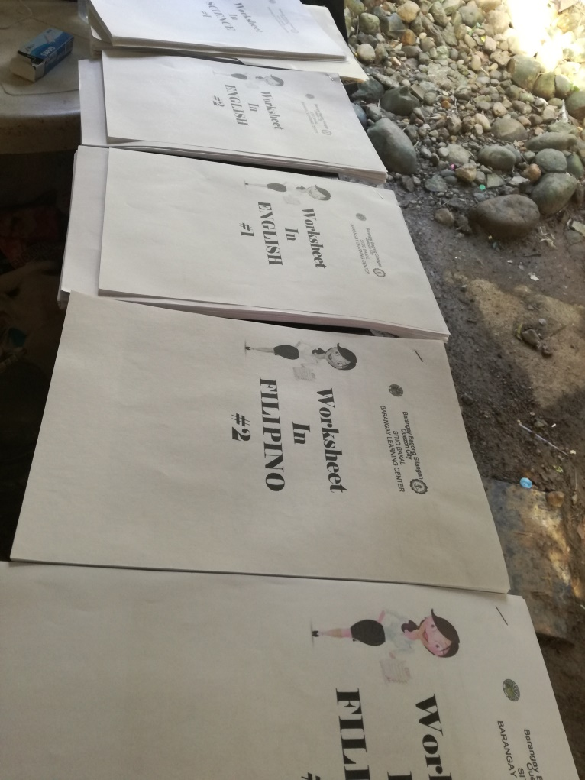
PREPARING MODULE AND GIVING HYGIENE KIT



