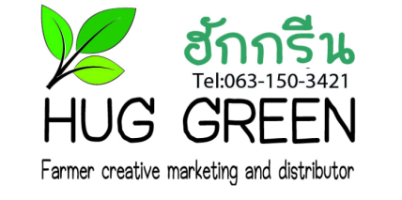
Hug Green Newsletter
-Many small pieces make a big piece-
November 2020, Mae Tha, Lampang, Thailand

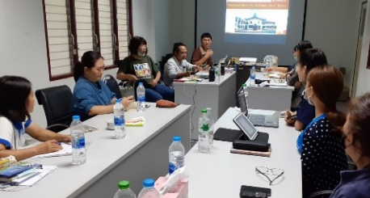
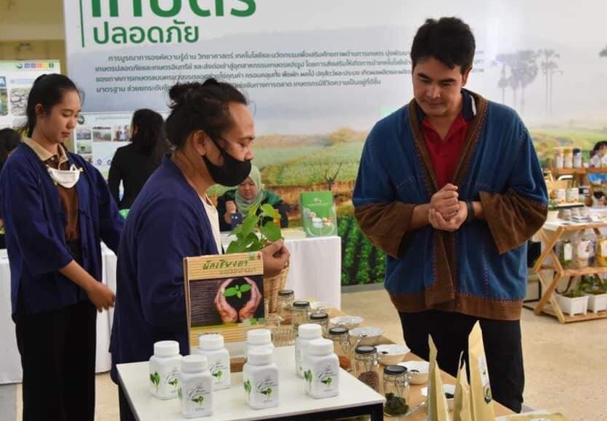
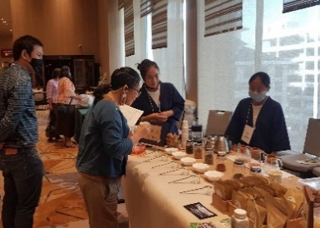
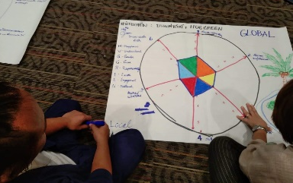
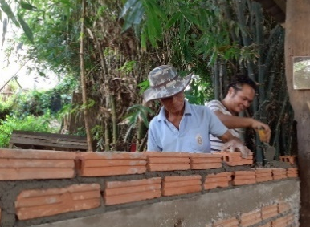
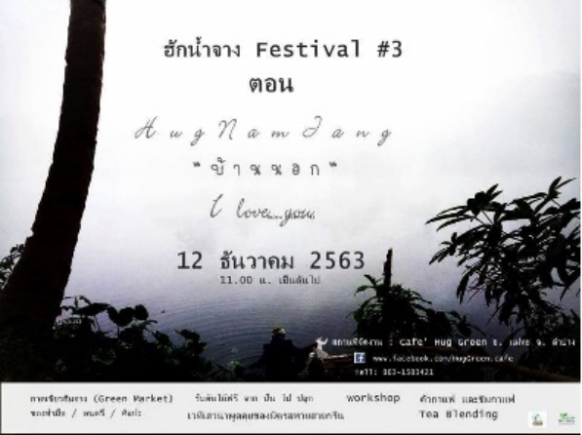
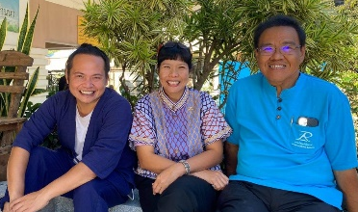
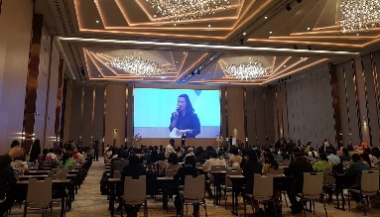
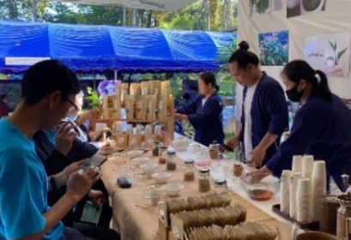
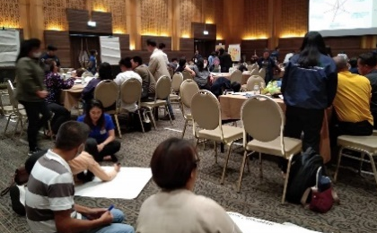
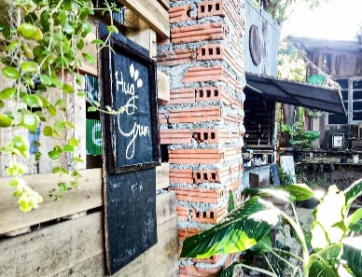
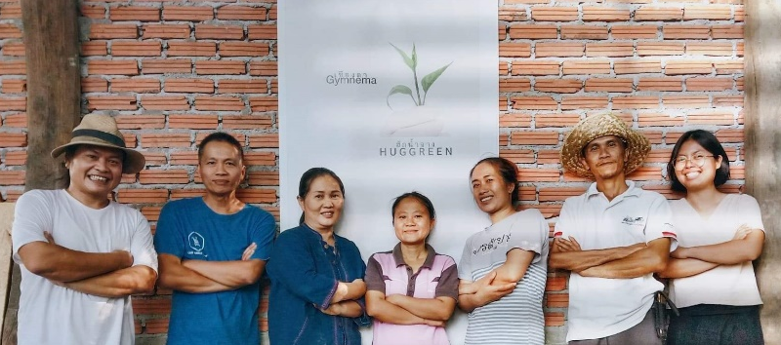
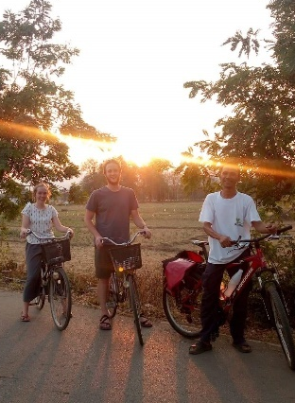
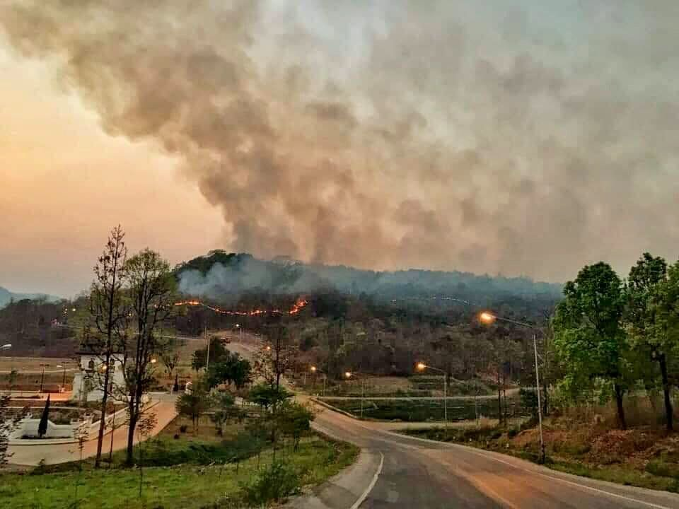
Meetings and tea blending at Rajamangala University
We had an opportunity to join in online meeting with Rajamangala Uni and YMCA Chiangmai as well as staffs in Myanmar and other provinces in Thailand. We back to university on the following day for tea blending where we had many customers stopping by to our stand. New intern Mon also joined in the meeting and tea blending. We are glad to meet more people who are interested in our tea and activities. We hope to have them to Hug Green soon and guide them around our place in village.
Invitation by BIOTHAI
Last Aug, BIOTHAI invited us to their regular market in Bangkok. In Nov, we were given the second chance fortunately for tea blending at their 2-day event. At the hotel, Hug Green introduced Gymnema herb tea product.
We are very grateful for BIOTHAI and new customers.
Seminar in Chiangmai
Khun Yong from Thammasat Uni brought us to 2-day seminar. We met other groups who has been working on environmental issues and community development. Some faces are familiar to us since we meet from time to time, and it reminds us that we keep working on the same track!
Hug Green in Dec;
-12 Dec, HUG NAM JANG FESTIVAL @Hug Green
-Building Green Shop which sells our products
*Hug Green is sometimes closed. Please feel free to contact before your visit!
Hug Green: 063-150-3421
3rd HUG NAM JANG FESTIVAL on Sat 12 Dec!!
We are preparing for yearly event!! Tentative program is; discussion for Hug Green next year projects, coffee roasting, tea blending, music, and around 50 shops such as “slow food”, Thai Coffee & Cocoa shop from Lampang. Due to spread of COVI-19, please follow our updates and strict rules of facial mask and check points.
We hope to see you very soon!

