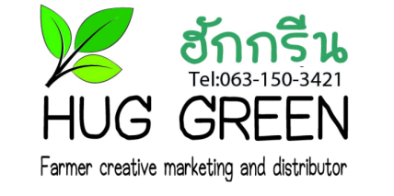
Hug Green Newsletter
-Many small pieces make a big piece-
October 2020, Mae Tha, Lampang, Thailand

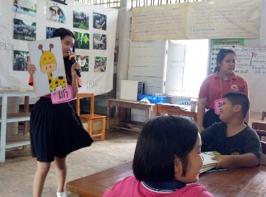
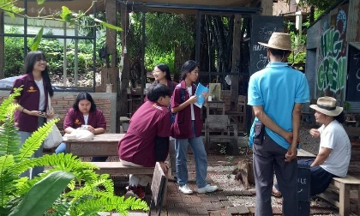
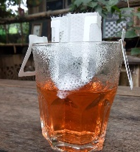
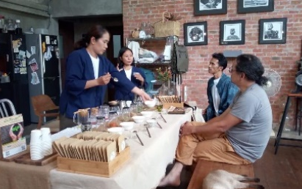
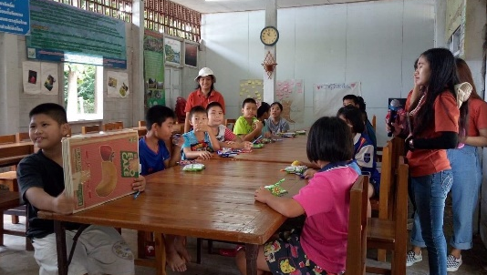
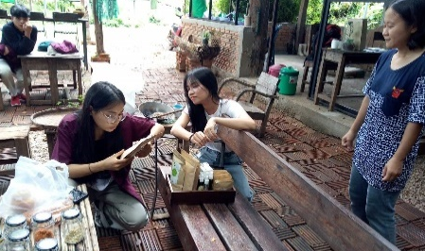
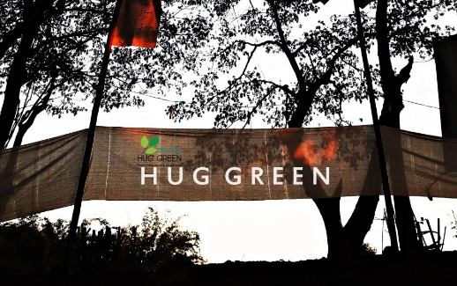
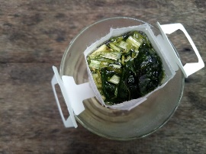
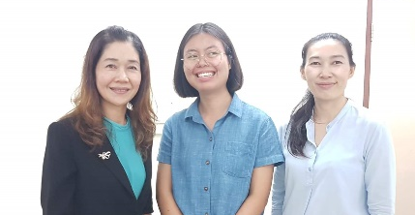
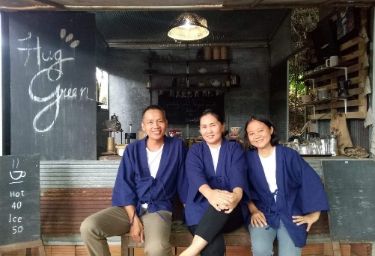
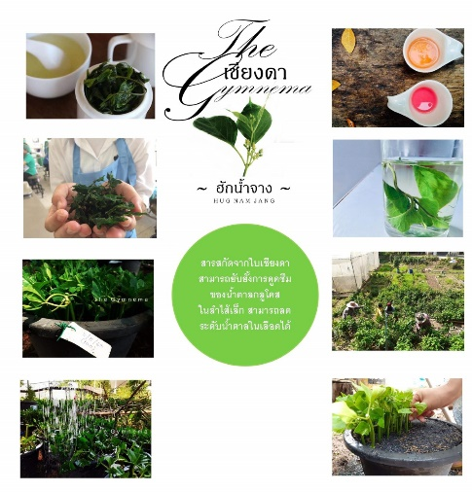
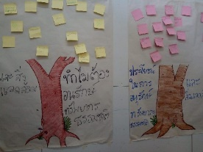
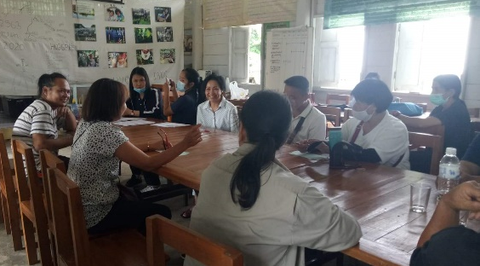
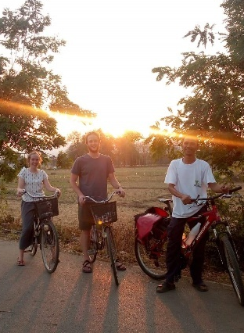
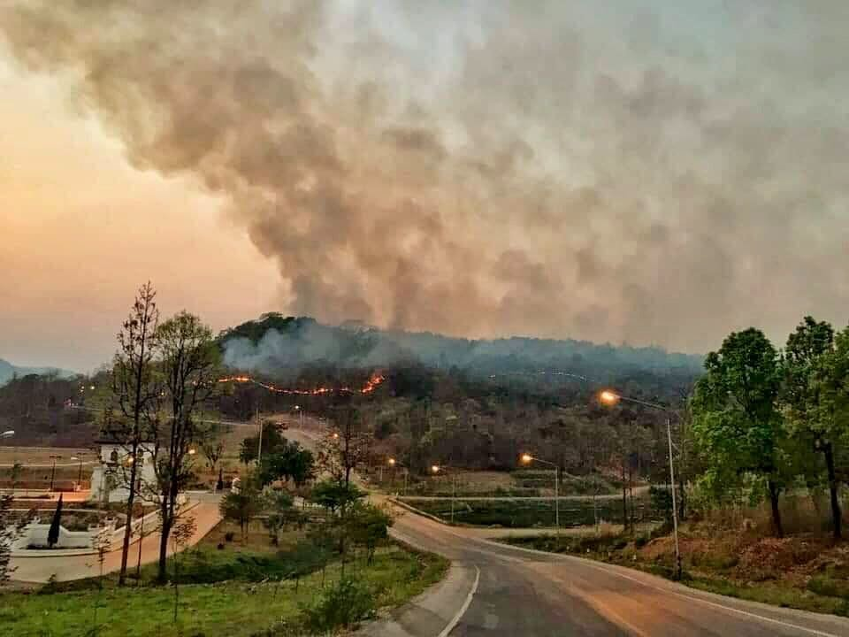
Hug Green in Nov;
-preparation for 12 Dec Festival!
-4,5 Nov, seminar in Chiang Mai (by Kru Yong’s invitation)
-9 Nov, web meeting with YMCA and Ajarn Aey at Rajamangala Uni (and 11 Nov, tea blending)
-25 Nov, tea blending at BioThai, GD Park in Bangkok
-building green shop
12 December Festival
We set the date for the 3rd Hug Nam Jang Festival on Sat, 12 Dec! Please mark the calendar, and we keep all updated about detailed schedule. There will be for sure green market, coffee roasting, tea blending, music, and good laughs!
New catalogue
As we have assisted developing product design of Hug Nam Jang, new design of catalogue is ready now for customers. It will help customers gain more knowledge about gymnema. We visited one designer in Chiang Mai to discuss new Hug Green logo! Although the designer liked our tea, we keep developing our tea products!
New “members”; intern & Hug Green jacket
In Nov, we will welcome one intern from NGO in Bangkok, thanks to Kru Yong’s support. One of our team met her in Bangkok before her arrival in Nov. Please come talk to our intern while her stay until May 2021.

Students from 3 universities visited us!
We are very grateful for young visitors this month. Students from Rajabhat conducted activities with kids in the village, teaching about environment and planting together (upper left photos). Students coming with Ajarn Pim from Rachamongkala visited for their Tourism class (above). Kru Yong from Thammasat also assign students to come. They study social work, which they try to support community through tourism (upper right). Very excited with their new ideas!

